

University of Greenwich ID Number: 001340304

FPT Student ID Number: GCD220030

Module Code: COMP-1752

Module Assessment Title: COMP-1752 Coursework

Lecturer Name: Nguyen The Nghia

Submission Date: 14th Aug, 2024

Object-Oriented Programming Project Report
Ho Dac Cong Vinh
UG Scholar,Computing department, FPT Greenwich University, Da Nang
City, Viet Nam
(Email : vinhhdcgcd220030@fpt.edu.vn)

Table of Contents
- Introduction
- Design
  - Overview
  - Project Structure
  - UI Design
    - Menu Sketch
    - Check Video Sketch
    - Create Video Playlist Sketch
    - Update Video Sketch
- Development
  - Stage 1
  - Stage 2
  - Stage 3
  - Stage 4
  - Stage 5
- Testing and Validation
- Conclusion and Further Development
- Appendix

- Introduction
Currently, in an era where technology has almost become an indispensable part of life. To meet people's needs at work, especially entertainment, there are many software and applications that have been created such as YouTube, etc. The above software has the characteristic of being able to play both video and audio. music, more specifically, we have the Spotify software that only focuses on music playback function. And to meet the needs of some users who want a software with a simple, easy-to-use interface as well as content management, especially it only focuses on video playback. I developed a software called Video Player. This software is inspired by the famous Spotify software in music-related platforms, and Video Player is similar, it allows users to manage playlists as well as video information in a detailed and easy way.

- Design
  - Overview
Utilizing the pre-built Tkinter commands, I have created a software application that enables users to control the program with just a few simple clicks. To assist users, the software will automatically assign consecutive numbers to all movies listed. Users can select and utilize unique features for every video. The software's user-friendly interface presents each function separately, allowing users to easily identify and access them. Users of the program can leverage each unique video for a range of purposes, including:
- List Video
- Check video
- Update rating
- CreateVideo
- Play Video
- Reset the playlist
-EXIT
  - Project Structure
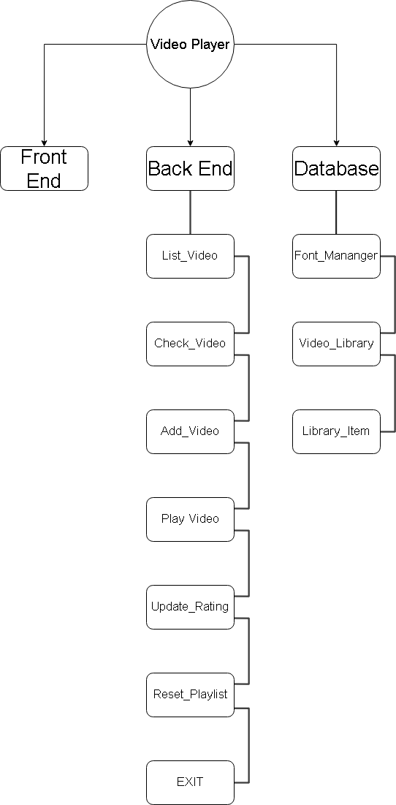

  - UI Design
This is the GUI of Video Player:
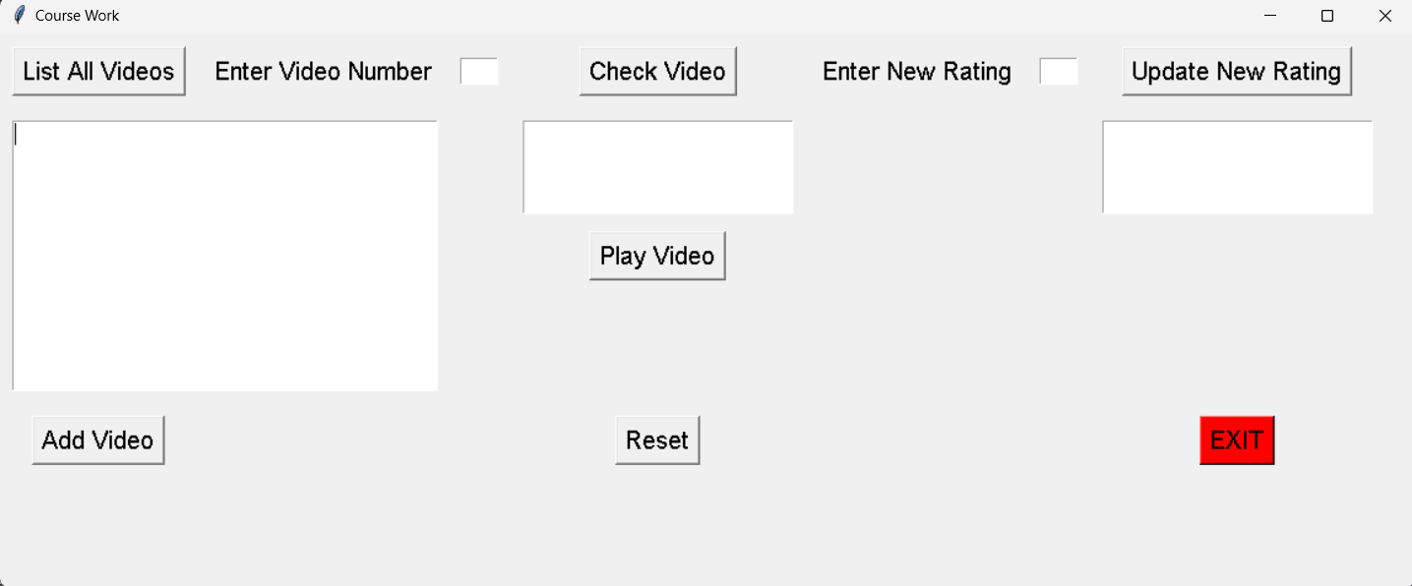

Button | Function | Condition
List All Videos | Users can better understand the content provided by streaming services. | User must press the “List All  Video” button to use the function.
Check Video | Users can easily get information about a specific video by entering the corresponding number. The app will display details like video name, director, rating, and play count | Users must enter the video number into the "Enter Video Number" box, then click the "Check Video" button to use this function.
Update New Rating | Users can update video ratings according to their interests. Whether they want to upvote their favorite content or give constructive feedback, the app lets them adjust their ratings | Users must enter the video number into the "Enter Video Number" box, then enter the rate number into the “Enter New Rating”, after that click the "Update New Rating" button to use this function.
Play Video | After adding a video to the playlist, users can watch the selected video without worrying about being interrupted by other notifications | Users must enter the video number into the "Enter Video Number" box, then click the "Play Video" button to use this function.
Add Video | Users can add favorite videos to playlists, creating collections suitable for users | Users must enter the video number into the "Enter Video Number" box, then click the "Add Video" button to use this function.
Reset | For users who want to reorder playlists or just want to clear everything, Video Player offers a reset option. With just one click, everything will be erased, allowing users to start again | Users must click “Reset” button to use this function.
EXIT | Users can close the software at any time with just one click without having to worry about the application running in the background on the device. | User must click “EXIT” button to use this function.

- Development
  - Stage 1
Video Player command lines are provided with comments
describing the operation of each function. You can view them here

  - Stage 2
The goal at this stage is to develop a user interface (GUI) that responds to user interaction. This stage needs to build two interfaces corresponding to the functions of "Update_video" and Create_video_list". The goal at this stage is to create interfaces that can be easily interacted with by users and are beautiful. By tailoring GUI components and their responsiveness to user input, the project attempts to create an interactive environment conducive to seamless navigation and efficient task performance.

  - Stage 3
This phase is to control the functions through the implementation of the corresponding functions integrated into the user interface in phase two. It is necessary for this phase to create functions specifically designed to facilitate the use of the "Update_video" and Create_video_list features". After completing the above requirements, the second purpose is to implement the functions. feature enhancements and functional optimizations This requires tweaking existing functions to enhance performance, scalability, and user experience.

  - Stage 4
At this stage, it is of utmost importance to test the stability of the system and identify any errors that may be encountered during operation, and to document these discrepancies. A key component of this quality assurance process includes the establishment of a “LibraryItem” system, built using PyTest, which serves the dual purpose of evaluating the performance of available functions and evaluating stability. of the Video Player's active database. Performing performance tests within this framework is expected to improve application reliability and responsiveness. The assessments obtained from these system tests will be stored to provide important feedback for improving the performance of the Video Player and enhancing its stability in the future.

  - Stage 5
During this final phase, assigned tasks included enhancing Spotideo's advanced functionalities, with a particular focus on redesigning the system to incorporate plates to unify the user interface( GUI).) The logic behind choosing these specific functions stems from their perceived significance in Spotideo's current stage of development, which is substantially concentrated on testing.

With the first invention" Redesign the system so it uses a single GUI". The decision to combine multiple windows into a single GUI interface in this software is to optimize user experience and ameliorate overall effectiveness. polarizing separate functions into one interface offers several advantages. It simplifies user relations by allowing users to pierce colorful features and tools in the operation without having to switch between multiple windows. This system not only minimizes the quantum of information users need to reuse but also promotes a more effective workflow. Overall, espousing a unified user interface prioritizes user- centricity to optimize functionality and enhance user experience.

Also, the user interface junction point is considered necessary to enhance user experience, making it easier for users to use the software accessibly. By optimizing these functions, the thing is to optimize user usability and promote product operation experience.

- Testing and Validation
  - Check list
No | Description | Input | Expected Output | Output | Evidence | Test  Result
1 | Test GUI | Start the application | Display a GUI as designed | Display a GUI as designed | Evidence | Pass
2 | Test “List Video”function. | Press “List All  Videos” Button | Notification “ List Videos Button was clicked” line appears | Notification “ List Videos Button was clicked” line appears | Evidence | Pass
3 | Test “Check Video”function. | Enter number “05” into “Enter Video Number” box and press the “Check Video”button | All details of the video included : Name, Director, Rating, Play appears, notification  “Check Video button was clicked!” line appears | Gone with the Wind  Victor Fleming  Rating: 3  Plays: 0  Notification  “Check Video  button was  clicked!” line  appeared | Evidence | Pass
4 | Test for wrong input of Check Video” function | Enter number “07” into “Enter Video Number” box and press the “Add To  Playlist” button | The phrase "Video 07 not found" will show in place of the video's  information. Notification “Check Video button was clicked!” line appears | Video 07 not found.  Notification “Check Video button was  clicked!” line appeared | Evidence | Pass
5 | Test “Add Video” function | Enter number “01” into “Enter Video Number” box and press “Add Video” button | All details of the video included : Name, Director, Rating, Play appears, notification  “Current Playlist: 01” line appears | Tom and Jerry  Fred Quimby  Rating : 3  Plays : 0  Notification “Current Playlist: 01” line appeared | Evidence | Pass
6 | Test “Play”function | Press “Play” button | Notification “Play clicked, please click reset button to add and play another video” line appears. When check video detail of  “Tom and Jerry”, the “Play” will  be increased to 1 | Notification “Play clicked, please click reset button to add and play another video” line appeared. The “Play of “Tom and Jerry”  was increased to 1 | Evidence | Pass
7 | Test “Reset”function | Press “Reset” button | Notification “Playlist reset!” line appears. All of the video into “Add Video” will deleted | Notification “Playlist reset!” line appeared.  All of the video into “Add Video” will deleted | Evidence | Pass
8 | Test “Update Rating”function | Enter number “05” into “Enter Video Number” box and enter “Check Video”. Then enter number “1” into “Enter New Rating” box. Press the “Update Rating” function | All details of the video in two box included : Name, Director, Rating, New Rating, Play appears and the rating will be “1” when “List Video” button clicked, the rating of video will  update to 1 stars, notification “The video rating was updated!” line appears | Gone with the Wind  Victor Fleming  Rating: 3  Plays: 0  and  Gone with the Wind  Victor Fleming  New Rating: 3  Plays: 0  The rating of video was updated to 1 stars Notification “The video rating was updated!” line appeared | Evidence | Pass
9 | Test for wrong video number of “Update Rating”function | Enter number “06” into “Enter Video Number” box and enter “Check Video”. Then enter number “1” into “Enter New Rating” box. Press the “Update Rating” function | The notification “Failed to update rating for video 06” displays,  “ Failed to update rating” line appears no video information is show in update box | The notification “Failed to update rating for video 06” displays,  “ Failed to update rating” line appears no video information is show in update box | Evidence | Pass
10 | Test for invalid  rating of “Update  Rating” function. | Enter number “01” into “Enter Video Number” box and enter “Check Video”. Then enter “abc” into “Enter New Rating” box . Press the “Update Rating”function | The notification “Please enter a valid number" displays, and no video information is show | The notification “Please enter a valid number" displays, and no video information is show | Evidence | Pass

  - Test List
- Test 1:
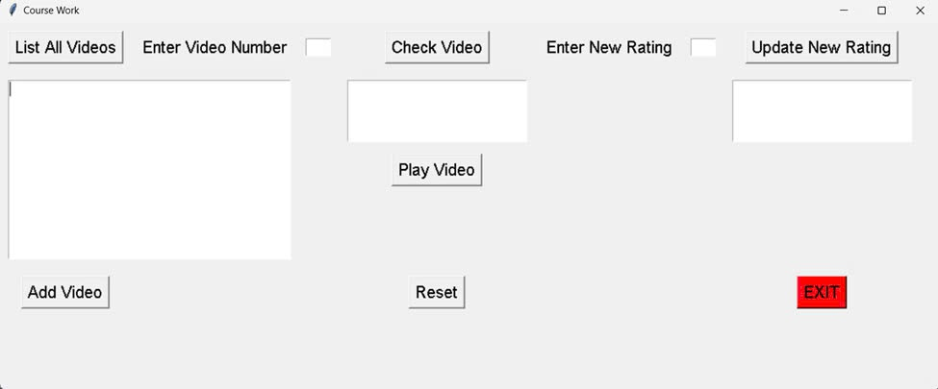
- Test 2:
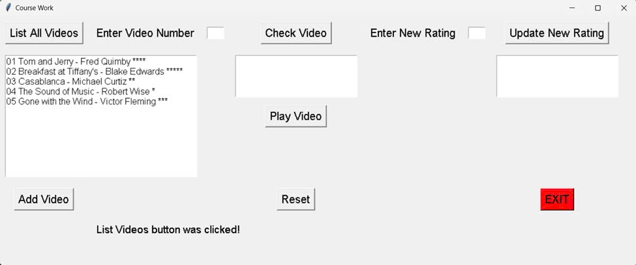
- Test 3:
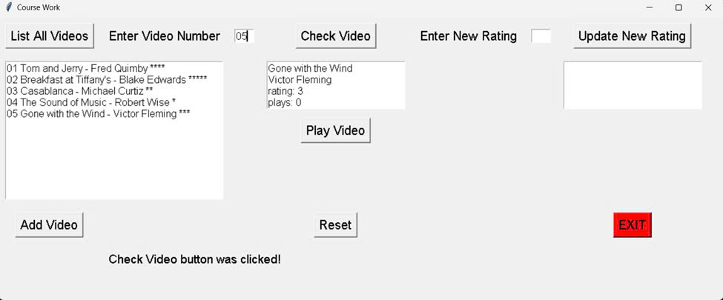
- Test 4:
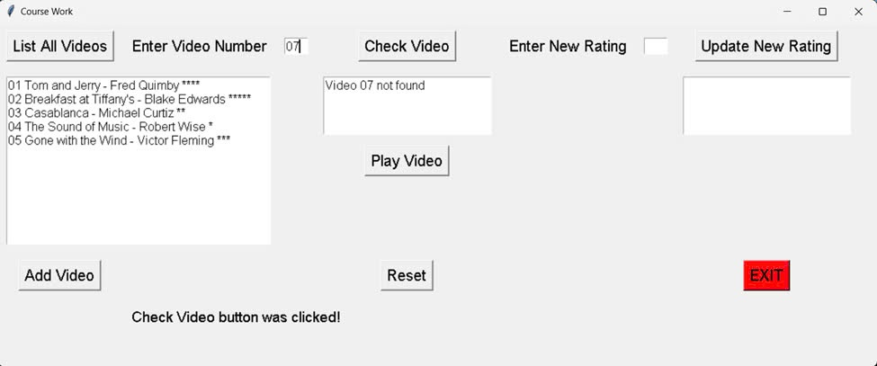
- Test 5:
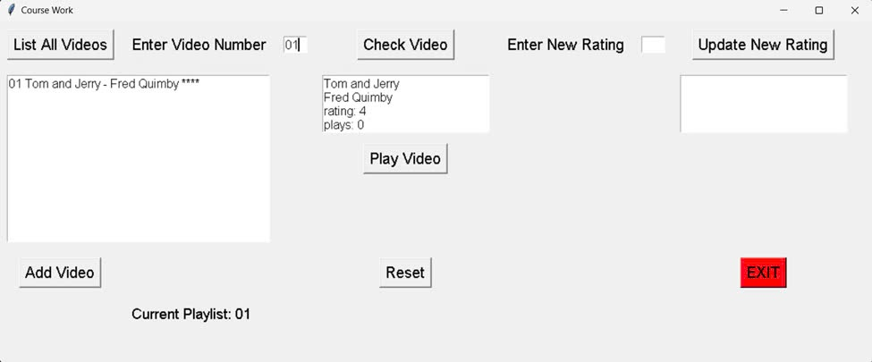
- Test 6:
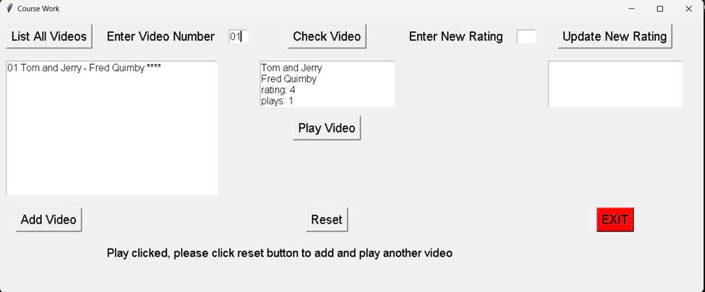
- Test 7:

- Test 8:
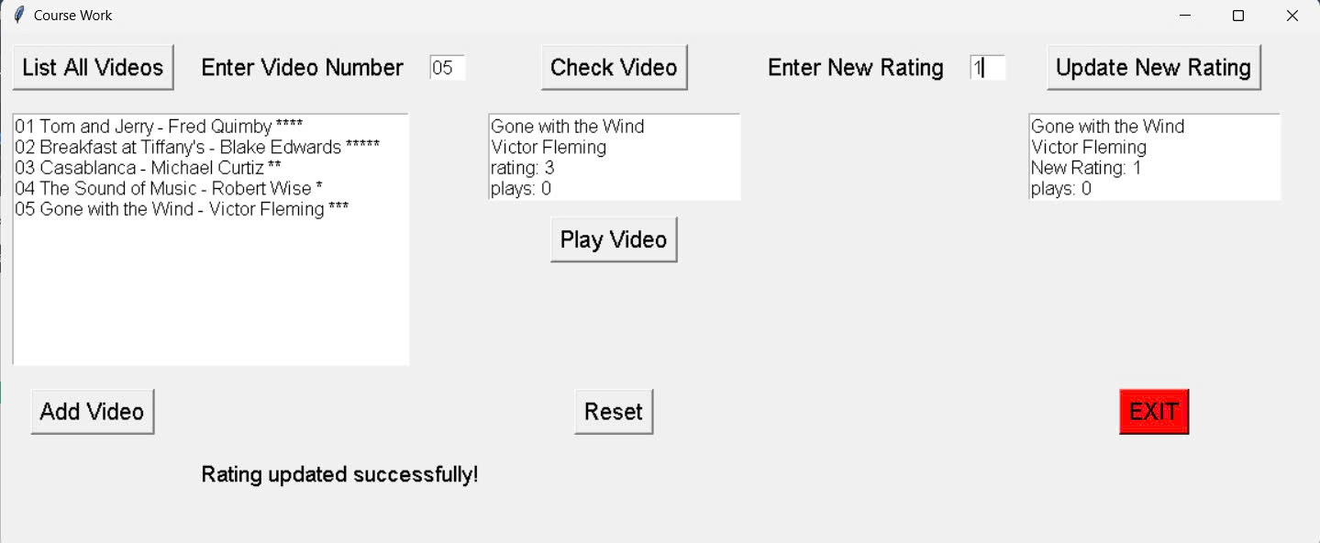
- Test 9:
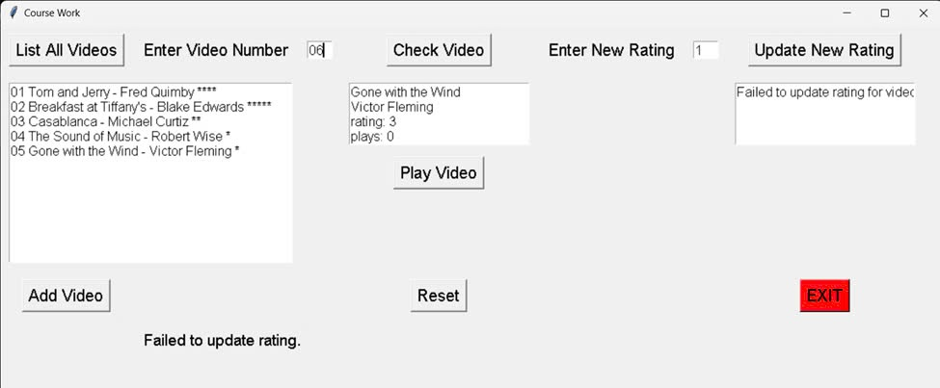
- Test 10:
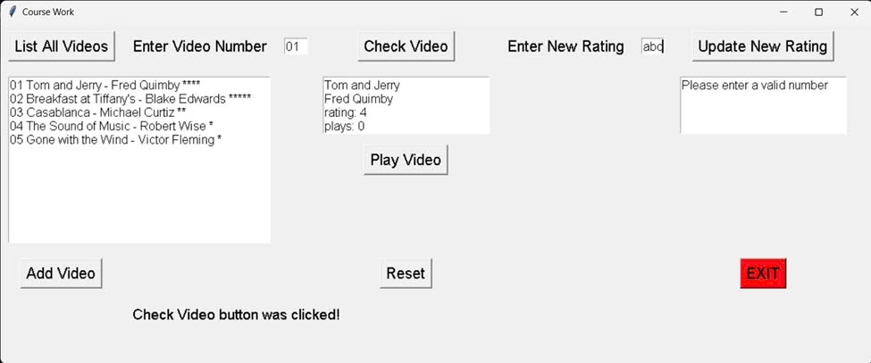
- Conclusion and Further Development
Video Player is an application that facilitates user interaction by providing access to a variety of video content, allowing users to select and interact with preferred material quickly. Video Player also has a powerful set of tools to effectively manage the user's video library as well as a simple interface. As a result, Video Player will grow as a potential competitor, meeting the needs and preferences of users looking for an enhanced video consumption experience.

In the future, I plan to improve Video Player by incorporating a number of features such as video sharing and granting access to third parties to increase user satisfaction. These enhancements will include user authentication and authorization functions, facilitating application access via user accounts. Furthermore, I would like to introduce a role-based access control mechanism, giving users the ability to adjust access to specific features. Finally, I plan to revise the user interface design, improving the layout and features while maintaining the aesthetics.

This course has provided me with valuable information on the fundamentals of application development, equipping me with the knowledge needed to create basic applications with essential functions. During the course, I participated in information sources such as classroom lectures, tutorial exercises, and Object oriented programming materials from online sources. I anticipate that the knowledge and experience gained through this course will serve as a foundation for my future experiences, allowing me to navigate complex projects at a higher level and meet meet the increasing requirements of this era. Therefore, I see this course as the foundation for realizing my career aspirations.
- Appendix
import tkinter as tk
import font_manager as fonts
import video_library as lib
def set_text(text_area, content):
text_area.delete("1.0", tk.END)
text_area.insert(1.0, content)
class Coursework():
def __init__(self, window):
self.window = window
window.geometry("1150x450") # window size
window.title("Course Work") # window title
enter_lbl = tk.Label(window, text="Enter Video Number")
enter_lbl.grid(row=0, column=1, padx=10, pady=10)
enter1_lbl = tk.Label(window, text="Enter New Rating")
enter1_lbl.grid(row=0, column=4, padx=10, pady=10)
# button
list_videos_btn = tk.Button(window, text="List All Videos", command=self.list_videos_clicked)
list_videos_btn.grid(row=0, column=0, padx=10, pady=10)
check_video_btn = tk.Button(window, text="Check Video", command=self.check_video_clicked)
check_video_btn.grid(row=0, column=3, padx=10, pady=10)
add_videos_btn = tk.Button(window, text="Add Video", command=self.add_videos_clicked)
add_videos_btn.grid(row=2, column=0, padx=10, pady=10)
play_video_btn = tk.Button(window, text="Play Video", command=self.play_count)
play_video_btn.grid(row=1, column=3, padx=10, pady=10)
reset_btn = tk.Button(window, text="Reset", command=self.reset_clicked)
reset_btn.grid(row=2, column=3, padx=10, pady=0)
update_rate_video_btn = tk.Button(window, text="Update New Rating", command=self.update_rate_video_clicked)
update_rate_video_btn.grid(row=0, column=6, padx=10, pady=10)
exit_btn = tk.Button(window, text="EXIT", bg="red", command=self.exit_button_clicked)
exit_btn.grid(row=2, column=6, padx=10, pady=10)
# text
self.input_txt = tk.Entry(window, width=3) # place to enter video number
self.input_txt.grid(row=0, column=2, padx=10, pady=10)
self.list_txt = tk.Text(window, width=38, height=12, wrap="none") # place show information video
self.list_txt.grid(row=1, column=0, columnspan=3, sticky="W", padx=10, pady=10)
self.video_txt = tk.Text(window, width=24, height=4,
wrap="none") # place show information after click check video
self.video_txt.grid(row=1, column=3, sticky="NW", padx=10, pady=10)
self.update_rate_txt = tk.Text(window, width=3, height=1) # place to enter rating number
self.update_rate_txt.grid(row=0, column=5, padx=10, pady=10)
self.new_rate_txt = tk.Text(window, width=24, height=4,
wrap="none") # place to show info after click update rate
self.new_rate_txt.grid(row=1, column=6, sticky="NW", padx=10, pady=10)
self.status_lbl = tk.Label(window, text="", font=("Helvetica", 14)) # place to show notifications
self.status_lbl.grid(row=100, column=1, columnspan=4, sticky="W", padx=10, pady=10)
self.list_videos_clicked()
def check_video_clicked(self):
key = self.input_txt.get()
name = lib.get_name(key)
if name is not None:
director = lib.get_director(key)
rating = lib.get_rating(key)
play_count = lib.get_play_count(key)
video_details = f"{name}\n{director}\nrating: {rating}\nplays: {play_count}"
set_text(self.video_txt, video_details)
else:
set_text(self.video_txt, f"Video {key} not found")
self.status_lbl.configure(text="Check Video button was clicked!")
def list_videos_clicked(self):
video_list = lib.list_all()
set_text(self.list_txt, video_list)
self.status_lbl.configure(text="")
self.playliststore = [] # place to store the playlist
self.playliststore_key = [] # place to store the key of videos in the playlist
self.current_video_key = None # Variable to store the current selected video key
self.filtered_list = "" # String to store the filtered video list
self.status_lbl.configure(text="List Videos button was clicked!")
def add_videos_clicked(self):
key = self.input_txt.get()
if key.startswith(
'-'): # startswith: Checks a value against a selected string and returns True if the string starts with that value.
self.status_lbl.configure(text="enter a valid number")
elif not key.isdigit(): # isdigit: true for all numbers, non-numbers = false
self.status_lbl.configure(text="enter a valid number")
return
name = lib.get_name(str(key).zfill(2))
if name is None:
self.status_lbl.configure(text="Video not found")
return
director = lib.get_director(str(key).zfill(2))
rating = lib.get_rating(str(key).zfill(2))
play_count = lib.get_play_count(str(key).zfill(2))
self.name = name
self.director = director
self.rating = rating
# Update filtered_list with the new video details
self.filtered_list += f"{key} {self.name} - {self.director} {self.stars()}\n"
# Update list_txt with the filtered video details
set_text(self.list_txt, self.filtered_list)
# Add video to playlist and update the display
self.playliststore.append(f"{name}\n{director}\nrating: {rating}\nplays: {play_count}")
self.playliststore_key.append(str(key).zfill(2))
self.current_video_key = str(key).zfill(2)
self.display_playlist() # Display updated playlist
self.update_status_label() # Update status label
def reset_clicked(self):
for key in self.playliststore_key:
lib.reset_play_count(self) # Reset the play count of each video in the playlist
self.playliststore = [] # Clear the playlist
self.playliststore_key = [] # Clear the keys of the playlist
self.display_playlist() # Clear the text area
self.filtered_list = "" # Clear the filtered list
set_text(self.list_txt, "") # Clear the list_txt text area
self.status_lbl.configure(text="Playlist reset.") # Update the status label
self.input_txt.delete(0, tk.END)
# Generate a string of stars based on the rating.
def stars(self):
stars = ""
if self.rating is not None:
for i in range(self.rating):
stars += "*"
return stars
def display_current_video(self):
"""Display the currently selected video in the text area."""
if self.current_video_key:
name = lib.get_name(self.current_video_key)
director = lib.get_director(self.current_video_key)
rating = lib.get_rating(self.current_video_key)
play_count = lib.get_play_count(self.current_video_key)
video_details = (f"Video {self.current_video_key}:\nName: {name}\nDirector: {director}\n"
f"Rating: {rating}\nPlay Count: {play_count}\n")
set_text(self.video_txt, video_details)
def update_status_label(self):
"""Update the status label with the current playlist."""
playlist_summary = " | ".join(self.playliststore_key)
self.status_lbl.configure(text=f"Current Playlist: {playlist_summary}")
def display_playlist(self):
"""Display the playlist in the text area."""
playlist_content = "\n".join(self.playliststore) # Join playlist items into a single string
set_text(self.video_txt, playlist_content) # Display the playlist in the text area
def update_playlist(self):
updated_playlist = []
for key in self.playliststore_key:
name = lib.get_name(key)
director = lib.get_director(key)
rating = lib.get_rating(key)
play_count = lib.get_play_count(key)
updated_playlist.append(f"{name}\n{director}\nrating: {rating}\nplays: {play_count}")
self.playliststore = updated_playlist
self.display_playlist()
def update_status_label(self): # Update the status label with the current playlist.
playlist_summary = " | ".join(self.playliststore_key)
self.status_lbl.configure(text=f"Current Playlist: {playlist_summary}")
def play_count(self):
if self.current_video_key is not None:
lib.increment_play_count(self.current_video_key) # Increment the play count of the current video
self.update_playlist() # Update the playlist with new play counts
self.status_lbl.configure(
text="Play clicked, please click reset button to add and play another video") # Update the status label
else:
self.status_lbl.configure(text="select a video to play")
def update_rate_video_clicked(self):
key = self.input_txt.get()
new_rating = self.update_rate_txt.get("1.0", tk.END)
if not new_rating.isdigit():
set_text(self.new_rate_txt, "Please enter a valid number")
elif not (0 <= int(new_rating) <= 5):
set_text(self.new_rate_txt, "Please enter a valid rating (0-5)")
return
success = lib.update_rating(key, int(new_rating))
if success:
video_name = lib.get_name(key)
director = lib.get_director(key)
updated_rating = lib.get_rating(key)
play_count = lib.get_play_count(key)
video_details = f"{video_name}\n{director}\nNew Rating: {updated_rating}\nplays: {play_count}"
set_text(self.new_rate_txt, video_details)
self.status_lbl.configure(text="Rating updated successfully!")
else:
set_text(self.new_rate_txt, f"Failed to update rating for video {key}")
self.status_lbl.configure(text="Failed to update rating.")
def exit_button_clicked(self):
self.window.destroy() # destroy GUI
if __name__ == "__main__": # only runs when this file is run as a standalone
window = tk.Tk() # create a TK object
fonts.configure() # configure the fonts
Coursework(window) # open the CheckVideo GUI
window.mainloop() # run the window main loop, reacting to button presses, etc

